G2GO Vending Machine User Manual

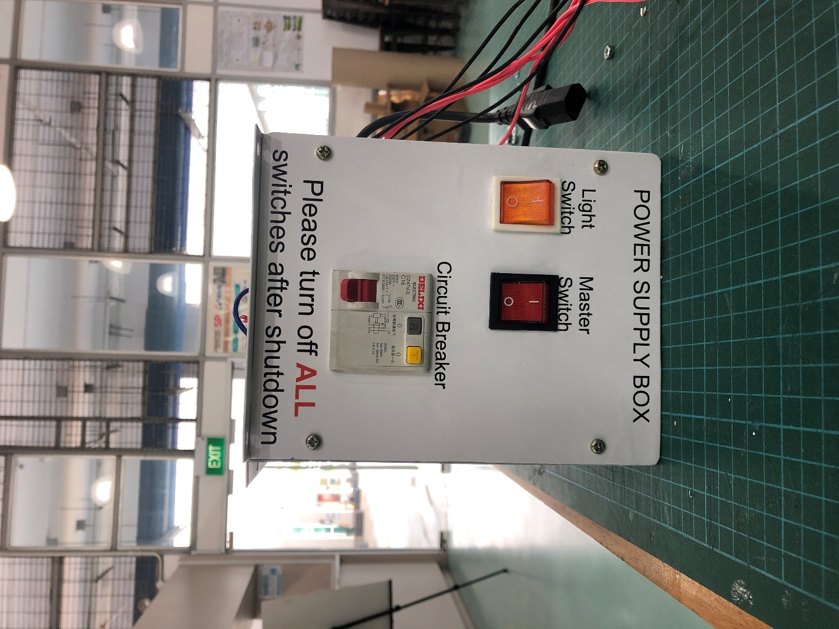

**Github: https://github.com/wendahere/GoGetter**

**Start-up procedure:**

1. Turn on the MCB and Switches on the Power Supply Box.
2. Wait for the Pi to boot.
3. The program will auto run.
4. Ensure that the Pi is connected to the internet beforehand.
   1. **Maintenance**

**Proper Shutdown procedure:**

1. Press Ctrl on Keyboard to close the program
2. Click the icon at top left of the screen to open start menu
3. Click on Shutdown..
4. A window will open, click on shutdown
5. After 30 seconds, shut off all the power in the vending machine
   1. Turn off the Circuit Breaker and Power Switches on the power supply unit
   2. Switch off the all plugs on the socket extension

**Importance of proper shutdown:**

1. SD Card might corrupt if power is turned off before the Raspberry Pi has shutdown
2. Surge in power might occur, damaging the Raspberry Pi or other electrical components

Not turning on:

1. Check if wall plug is turned on
2. Check if Power Supply Box switches are all turned on
3. If Red switch does not have light, Black 3 pin cable connected to outside of power supply unit might be faulty (fuse in socket head blown)
4. Check wire connections inside power supply box. Turn off all power connected and unplug all sockets. Unscrew 4 screws at front and side and check if any wires are loose/crimps disconnected. Reconnect any disconnected crimps/wires. If multiple is disconnected, follow picture guide on where to connect.
5. Check if Power Supply Unit has green led at wire connection area. If it does not and power is turned on, power supply unit needs to be repaired/replaced. (Replace fuse in Power Supply Unit)

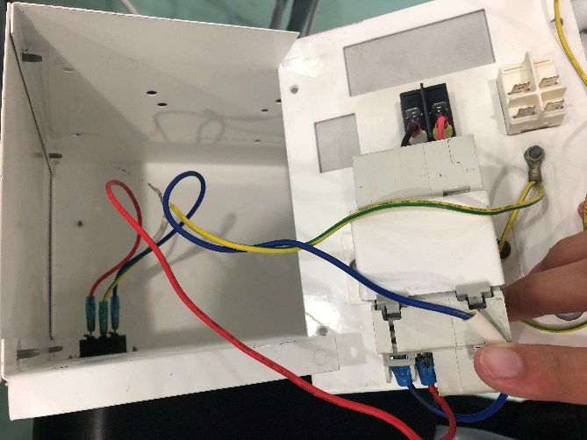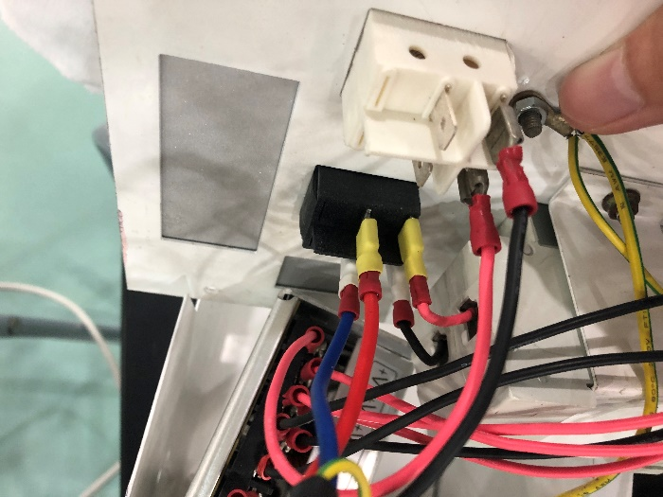

Please take note of the colors of wires  
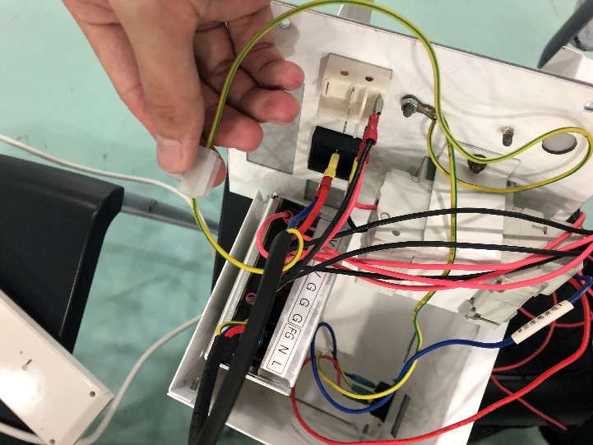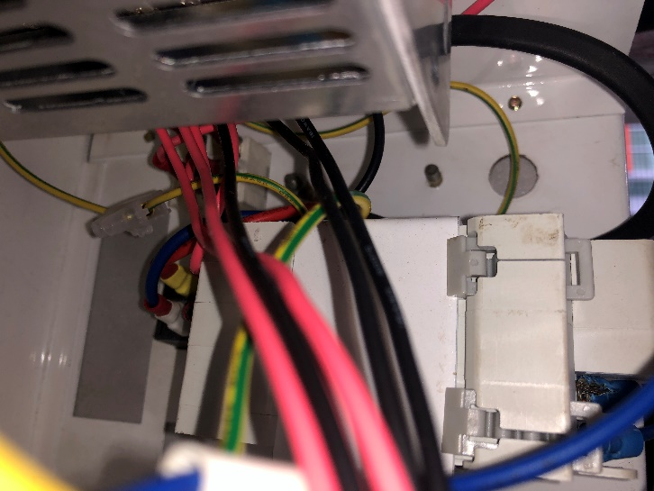

Green wire has to be grounded and plugged into the power supply unit.

Raspberry Pi no Display

1. Check if power is turned on
2. Check if Raspberry Pi has lights turned on, if not power supply of the Pi is faulty and needs to be replaced.
3. Check if HDMI Port connected is HDMI 0 instead of 1.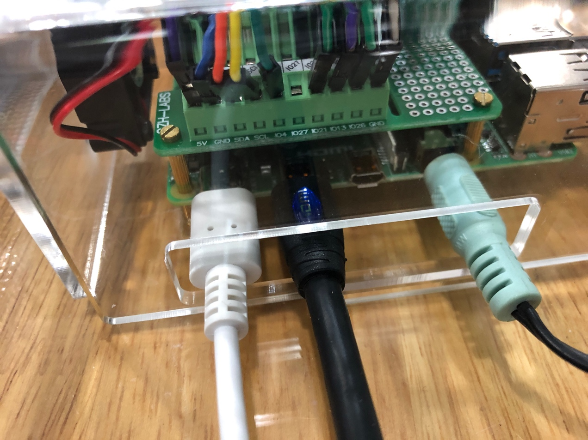
4. Check if Display micro USB is connected (power cable) . If it is and no display, cable might be faulty, replace USB to Micro USB cable.
5. Check if LCD Screen is working by using an external monitor. Power the external monitor and plug the HDMI cable from the LCD Screen to the external monitor. If there is display, the LCD Screen is faulty. If there is no display, Raspberry Pi is not working.

**Raspberry Pi not working**

1. Reflash the SD Card using Win32DiskImager software. File of image is following link:   
   Raspberrypi. (2020). Installing operating system images using Windows. Available: https://www.raspberrypi.org/documentation/installation/installing-images/windows.md. Last accessed 4 Feb 2021.
2. Replace Raspberry Pi 4

**Code not auto running on startup**

Manually open by opening terminal (Top left Black box icon) type “sudo python3 /home/pi/Desktop/VendingMachine/main.py” case sensitive.

Configure auto start following these instructions:

In Terminal, type and enter

“sudo nano /etc/xdg/lxsession/LXDE/autostart“

In the text editor, ensure that the file is exactly as below:  
”  
@lxpanel --profile LXDE

@pcmanfm --desktop --profile LXDE

@/home/pi/Desktop/VendingMachine/main.py

@xscreensaver -no-splash  
”

The line “@/home/pi/Desktop/VendingMachine/main.py” is the path to the code, main.py.

**Making changes in code to change points/audio etc:**

Press Ctrl to close vending machine program, use the mouse and double click and open the folder on desktop “VendingMachine”.

Right click main.py and choose open with thonny editor.

-Scroll to line 63 to change points.

-Line 83 onwards to edit RGB LED Strip color, Color(x,x,x) the numbers in the bracket is the color code.

-Line 49 is the speed of LEDs lighting up one by one. Time inbetween is wait_ms/1000. Seconds.

-Line 467 onwards to **edit text / text location of user interface**. Change Row to change text order. Change text inside text=”…” to change text.

**To change any audio files or images, replace the audio or image file in the folder** “VendingMachine” to it’s exact counterpart by changing the name of the old file and pasting the new file with the correct name.

Eg, replacing plstapyourcard.wav, rename its file to plstapyourcard_old.wav and put the new file with the name plstapyourcard.wav.

Ensure that the audio file format is 16 bit wav.

Ensure that the image file is png.

**Motor not working:**

Only few/one motor(s) are working:

1. Pull out the tray
2. Check the wiring on the motors
3. Check if any wire came out from the crimp
   1. If any wire escaped from is crimp, remove the crimp
   2. To reuse the crimp, use a plier or similar tool, clamp down on the circular aluminum part of the crimp and insert the escaped wire.
   3. Clamp back down the circular aluminum of the crimp and insert back the crimp to the motor.
   4. To use a new crimp, simply put the exposed part of the escaped wire in the circular part of the crimp.
   5. Crimp down using a crimping tool or plier.
4. Check on the PCB if any wire has come out of its terminal. All of the wires are labelled, unscrew the terminal, put the copper part of the wire in the screw terminal and screw down the screw on the screw terminal gently. (If the wire is labelled 1 and is black, plug into GND-1, if it is labelled 3 and is red, plug into GPIO V3)
5. If all above does not work, replace the faulty motor

All of the motors are not working:

1. Check if manual mode is able to move any motors
2. If not, check wiring on PCB if correct.
3. Ensure that Power Supply Unit is turned on
4. Check the red wires if there is any break
5. Replace PCB if above does not work

**RGB Strips faulty**

Have lights but colors are flickering:

1. Ensure that Green and Black wires and properly connected to the Raspberry Pi (From bottom row)
2. Ensure that there is no break in black wires in the screw terminals

Have lights but some LEDs colors are flickering:

1. Check wires on row below the flickering row
2. Ensure all wires are connected and screwed in tightly
3. Check top row wires to see if there are any disconnected wires

None of the lights are lighting up

1. Pull out bottom tray
2. Check if buck converter (Blue Board), wires are connected
3. Check green wire from bottom row to the Raspberry Pi is properly connected
4. Restart program to resend code to the RGB LEDs to make them light up